
Tom Girolamo
1058 DuBay Drive Mosinee WI 54455715-344-2817www.eco-buildingandforestry.com
Company Position | Owner, Manager, Forester since 1988 |  | 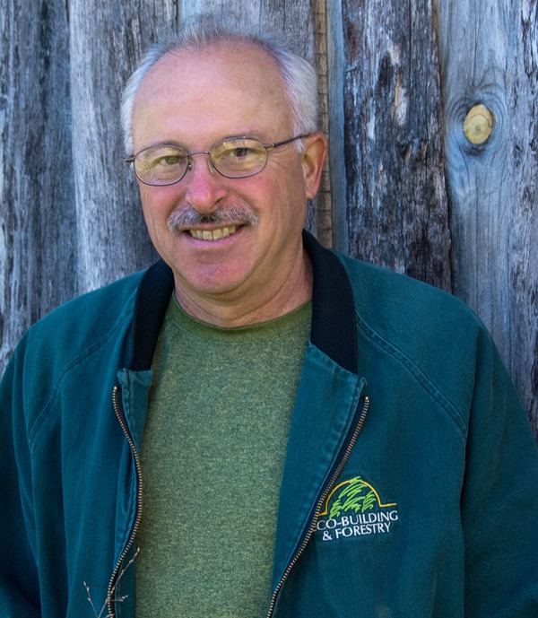
Education | 1982 UW-Stevens Point, B.S. Degree in Forestry  Emphasis: Forest Management  Urban Forestry  2005 Permaculture Research Institute, Certificate in  Permaculture Design, PRI-Australia  1996 Entry Level Firefighter Certificate
Forestry, Agri-Forestry, Small Agriculture, Alternative Ag., Permaculture | Trained in intensive forestry methods in the Black Forest in Germany. Trained by Australian agri-forestry specialists in dry climate agriculture systems. Small plot agriculture design and installation. Uses of perennial food plants. Design of swale systems for water retention. Small plant nursery construction and specialized growing methods.
Business Development | Designs, installs and manages resources on properties to produce multiple sustainable benefits for the owners and users of commercial, residential and farm properties.
Speaker | A sought after speaker for a variety of audiences interested in green building and sustainable landscapes.
Author, Awards and Accomplishments | Holder of 7 trademarks for landscape products and services.
Author, Awards and Accomplishments | 2009 | Published book, that is available internationally. Your Eco-Friendly Yard . Designed to assist property owners with creating benefits from their property including food and fiber production with limited inputs.
 | 2007 | Electronic Book. Permaculture for Cold Climates. This original work includes unique materials and methods for sustainable properties developed by Tom Girolamo.
 |  | Backyard Habitat Award. Given By the Central Wisconsin Chapter of the Audubon Society to the Midwest Renewable Energy Association for its landscape which was designed by Eco-Building & Forestry, LLC.
 | 2003 | Electronic Book. The Landscape is Changing: A guide to Alternative Landscaping; This original work includes unique landscape materials and methods for sustainable landscapes developed by Tom Girolamo.
 | 2003 | Lake Stewardship Award Winner-Business.
 | 1995 | Began installing high efficiency wood heating and wood cooking systems.
Special Skills | Natural Resources: Understands soil, water and plant relationships in small agriculture  systems.  Create Benefits: Ability to find or create multiple benefits for each action taken in the  environment.  Efficient Wood Fuel: Designed and built 2 wood-fired brick ovens, 3 masonry heaters and  uses small wood gasification units for cooking. (I can cook too!)  Efficient Water Use: Designs and uses drip irrigation, pond systems, cisterns, micro-  irrigation. on-contour and vegetated swales.  Small Chicken Flocks: Used for weeding, egg production, fertilizing and composting.  Small Tools: Use and development of small hand and powertools for ag and forestry.
Previous Work Experience | ۰City of Stevens Point, Wisconsin Municipal Arborist ۰Wisconsin Department of Natural Resources ۰U.S. Forest Service References Upon Request

